Using Available Resiliencies in Signing US-Afghan Security Agreement After 2014
By: Amanullah Hotak

Should USA and Afghan Governments Stand on Their Own Words or Respect Their Nations’ Interest Before Signing A Stalled Security Pact?
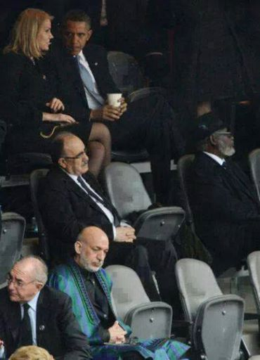In order to bring peace, security and development most Afghan government’s international supporters, from the very beginning, lend their hands frankly. This is what the history will record and no one will ignore it. If it is so, then who benefited, the nation or the elite with power and credit before these international supporters? If million and million dollars of these supporters have been spent to bring peace, security and development then where are these variables to see that their efforts and supports have been in place. Present Afghan nation and the world is witness of such uselessly spent million and million dollars’ support; neither there is peace nor there is development. The nation knows there have been huge support from the international friends and that there have been huge amount of dollars powering into the country, so where did it all go? If we turn to the nation’s resiliencies and study this question in their account, then who will the history take responsible for the case?
This status has put both the Afghan and the United States governments and the United States’ alliance in Afghanistan in a position to be more proactive afterwards in taking any upcoming step to provide assistances to Afghan government after 2014. Therefore, the United States government, led by Mr. Barak Obama, presented a draft of security pact (Bilateral Security Agreement) to Afghan government to be signed by president Karzai. President Karzai also had his country’s conditions and wanted Barak Obama to respect Afghan president’s conditions,then he will sign the agreement. Obama ignored Mr.Karzai’s conditions and insisted to sign US presented bilateral security pact.
Mr. Karzai did not sign the pact as the security pact was conditional on the United States stopping raids on Afghan homes and helping to restart a peace process with the Taliban. It is said that without a signed agreement, all U.S. troops would leave at the end of next year, along with all foreign forces.
Afghan president's ties with the United States government have been tense by his refusal to sign a security agreement that will shape the U.S. military presence in Afghanistan beyond 2014 when most international troops will leave the country. The United States and NATO say that, without these agreements, they would have to pull all of their forces, currently 84,000, out of Afghanistan by the end of 2014 in case security pact is not signed by president Karzai.
Mr. Karzai has struggled off U.S. talk of a total military pullout from Afghanistan if he does not sign the security agreement as brinkmanship and said he would not back down on his conditions for the deal.
The two presidents, after the refusal, started struggling to convince each other to respect his stance in line to agreement’s conditions. President Obama sent persuasive messages to Mr, Karzai and tried to motivate him by delivering speeches to his nation and in contrast president Karzai had visits from some strategic friendly countries to get their thoughts and if convince them to back up his stance as it appeared in his trip to Iran. Mr. Karzai stress on his conditions terming them as reflecting the present situation of the country and the wish of his nation. In his last trip to India Mr. Karzai reiterated and told reporters in New Delhi that the security pact was conditional on the United States stopping raids on Afghan homes and helping to restart a peace process with the Taliban.
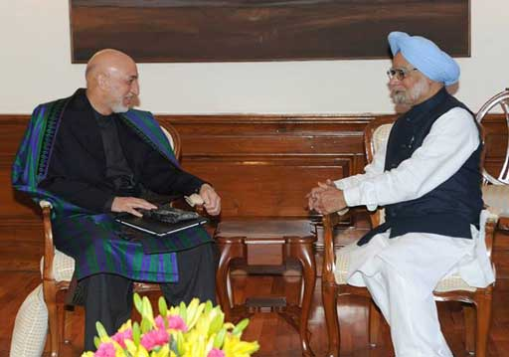
There has been much on world’s media about these stalled negotiations, blaming one side or the other. Most high ranking concerned military officials expressed their views and some had visits from their military personnel still present in Afghanistan, as well. Chuck Hagel, US Defense Secretary during his visit to Afghanistan said, “A NATO meeting in coming February could become a new deadline for a security pact between the United States and Afghanistan, whose president has been reluctant to sign the deal” ‘Reuters’. Hagel arrived in Afghanistan on Saturday to visit troops and senior Afghan officials but, unusually, did not plan to meet President Hamid Karzai, who has resisted signing the Bilateral Security Agreement (BSA) which would govern the U.S. military presence after most NATO forces leave by the end of next year. Hagel has added to say, "I would say that one of the things that you might want to look at is the NATO defense ministers’ ministerial meeting in the end of February," he said, suggesting a possible deadline. "Some answers are going to be required at that NATO ministerial."
Mr. Karzai, on the other hand has said he wants to wait until after April elections to conclude the deal, but Hagel said that could delay any signing until mid-2014, which he said was undesirable.
A year-long negotiation over the text of the document was thought to have been concluded last month when an assembly of Afghan tribal elders, civil society representatives and politicians, called a Loya Jirga, to look at the draft and provide their advice and feedback to Mr.Karzai on the pact’s contents. As observed this did not work well, as western media broadcasted, because Karzai surprised everyone during concluding remarks by saying he still had important demands. They relate to a desire for the United States to kick-start a promising peace process with the Taliban, and an end to raids on Afghan homes by U.S. forces pursuing militants.
Some American circles, pro-American civil societies and politicians in Afghanistan and those cabinet members who have hidden differences with Mr. Karzai tried to put pressure on him to sign the agreement prior to the deadline, others even gave warning, but he resisted and ignored signing the pact. So, the question then is will he bow to all these pressures?
During Hagel’s stay in Afghanistan he said he did not think additional pressure from U.S. officials would be helpful or persuade Karzai to sign the bilateral security agreement according to the U.S. timetable — by the end of December. Karzai says he wants his successor to decide after the April 5 elections.
Despite Hagel's assertion that pressuring Karzai may not prove productive, both Hagel and Marine Gen. Joseph Dunford, the top U.S. commander in Afghanistan, issued separate warnings about the approaching U.S. deadline.
As his hectic visits of Afghan friendly countries showed he is optimistic of having support from his nation and if few circles are against his stance that will not weaken his decision. Still president Karzai is suggesting other way to ease this stalled agreement’s distrust as he says he wants his successor to decide after Afghanistan's April elections, and has stood his ground in the face of unrelenting pressure from diplomatic and defense officials.
In some unofficial discussions president Karzai has disclosed that if Obama or any other leaders take steps for their nations’ interest why not Afghan president take a stance that is for the interest of Afghan nation. Now, if the fact is nations’ interest and the two sides stress on that then the question is ‘have the two leaders shared the idea with their nation for their inputs and consensus, or not and if yes, what has been the nations’ resilience?’
At nation-level consensus in Afghanistan, there have been some trivial political, civil society representation and the elements in Karzai’s cabinet, which raised their voices through Medias and gathering, but have not been so pervasive among Afghan community. These circles also tried to put pressure on Mr. Karzai to sign agreement ignoring his conditions. His resistance against such pressure was strong enough as majority of nation’s representative held special meetings and discourses assuring him of their support. Such influence was not broadcasted in local or world’s media that he, in a very little time, managed to obtain support of the majority of the nation. Instead voices of small groups or individuals were watched and heard much on radios and TVs. This gave Mr.Karzai dare to stand on his words and does not bow to internal or external pressure to give up his resistance and sign the agreement. So, what happened then?
Well, with the clock ticking on the present 49-nation mission ending before 2015, NATO and U.S. officials have said they must have agreements in place very soon to govern what happens afterward or risk being forced to withdraw all alliance (84,000 soldiers) and 60,000 of whom are American soldiers.
On the other side NATO, considering such present political context, started own talks with Afghanistan officials on Saturday ( 21 Dec.) They started work on drawing up a framework for NATO to stay on after 2014 regardless of the fact that agreement with USA is not signed.
Observers believe that the NATO-Afghan pact to be signed would have many of the same provisions as the U.S. one and would not be able to be concluded until after the U.S. agreement was signed.
Rueters reports, “Negotiations are designed to make the best use of time” said a NATO official, who withheld his name. “Time is of the essence here,” he added.
On the base of the report, the source said that the talks were launched at a meeting in Kabul between Mr. Maurits Jochems, NATO's senior civilian representative and Mr. Rangin Spanta, Afghan National Security Adviser in Kabul.
http://news.yahoo.com/hagel-given-assurances-afghan-security-deal-143510508--politics.html

