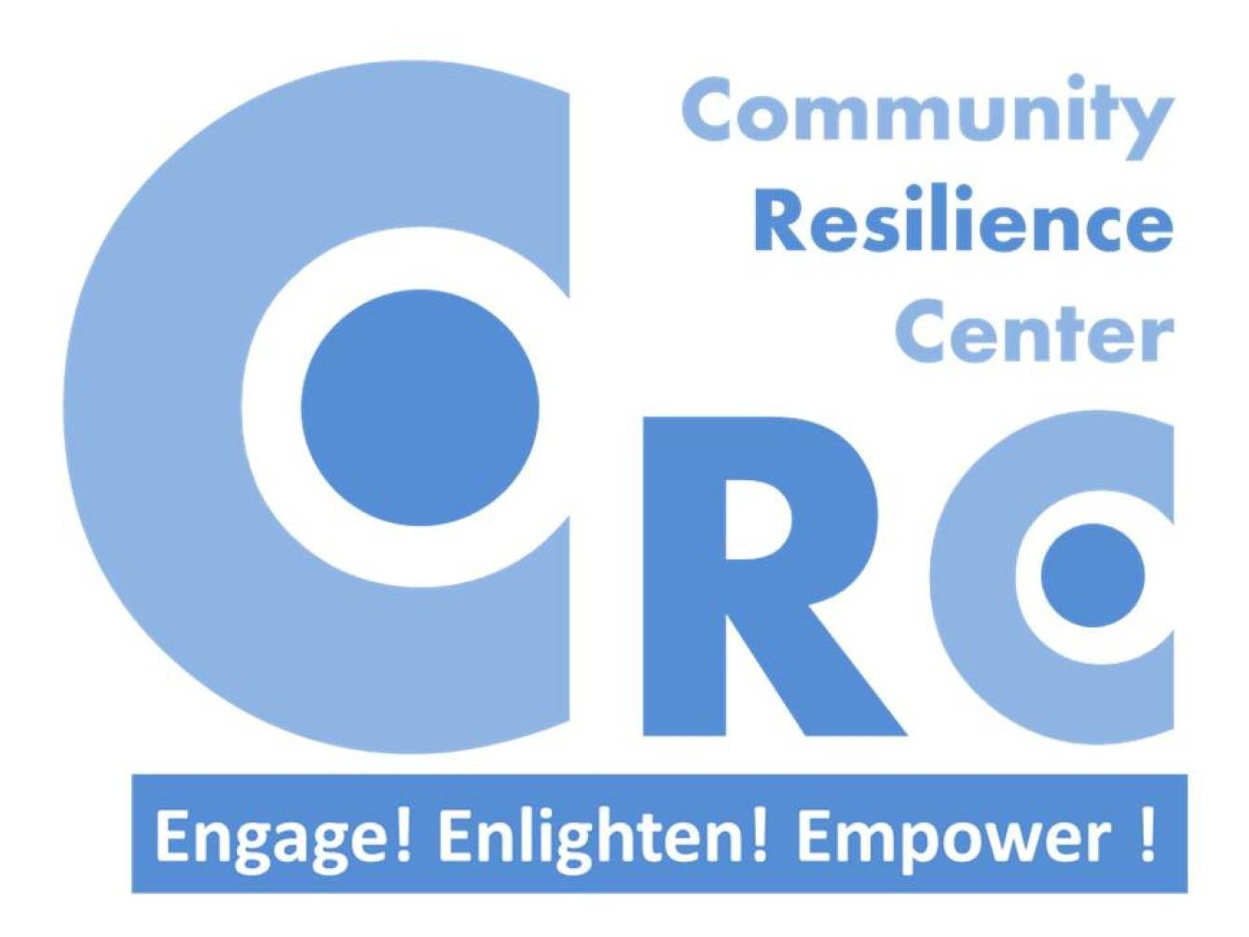

Community Resilience Center
194, Koskanaththa Road, Mampe, Piliyandala, Sri Lanka
Tel: 94718951089 Email: novil.wijesekara@gmail.com
Website: www.communityresiliencecenter.org
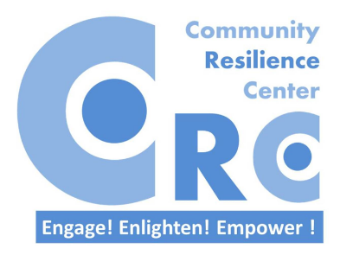
Community Resilience Center

Community Resilience Center is a community-based organization in Sri Lanka with the aim of promoting community level resilience to disasters.

Vision
A safe world where people will live in love, dignity and opportunities for growth.

Mission
To engage, enlighten and empower communities to promote resilience.

Objectives

- To promote continuous professional development of membership towards enhancing resilience.
- To engage communities and all relevant stakeholders in an inclusive manner towards promotion of community resilience.
- To promote the understanding and application of community resilience.
- To develop, disseminate and evaluate tools and techniques to assess and enhance community resilience.
- To innovate, implement and evaluate methods to improve community resilience.

Board of Directors

Dr. Novil Wijesekara – Honorary President
(Medical Officer, Disaster Preparedness and Response Division, Ministry of Health, Chairman Board of Trsutees – Community Tsunami Early-warning Center, National Disaster Resilience Awardee, Community Solutions Leader/US State Department Fellow 2014.)
Dr. Rajeev Pagoda – Honorary Vice President
(Commissioned Officer – Sri Lanka Air Force)
Mr. Tyronne J. Anthony – Honorary Secretary
(Fire and Safety Engineer, Council Member, Institute of Fire Engineers, Sri Lanka Branch)
Mr. Sumedha Devapriya – Honorary Treasurer
(Managing Director – Ecowave Travels Pvt Ltd, Community Solutions Leader/US State Department Fellow 2013.)
Mr. Nuwan Chamara Ekanayaka – Honorary Executive Director
(Master Trainer – Emergency Medical Technician, Mediasia Group (Pvt) Ltd), Fulbright Fellow, US Department of State)
Mr. Suchith Abeywickrama – Honorary Committee Member
(Education Consultant, Arigatou International, Conflict and Peace Studies Specialist,Community Solutions Leader/US State Department Fellow 2013.)
Mr. W.T.Roshan – Honorary Committee Member
(Manager – Community Tsunami Early-warning Center, Safety and Security Specialist)
Ms. Ruwanthi Elwalagedara – Honorary Founder Member
(Conflict Resolution Specialist, Community Solutions Leader/US State Department Fellow 2014.)

Some activities carried out by
The Community Resilience Center in 2015

- “Leading and managing volunteers in disaster response” training
Leading and managing training for Core Group in Disaster Response,
Faculty of Medicine, University of Colombo
The Core Group for Disaster Response is a student organization involved in disaster response at the Faculty of Medicine, University of Colombo. This training was conducted in two sessions in order to provide maximum interaction with them despite their busy faculty calendar. Thirty three (33) medical students participated in this two day training. The participants were issued a certificate.
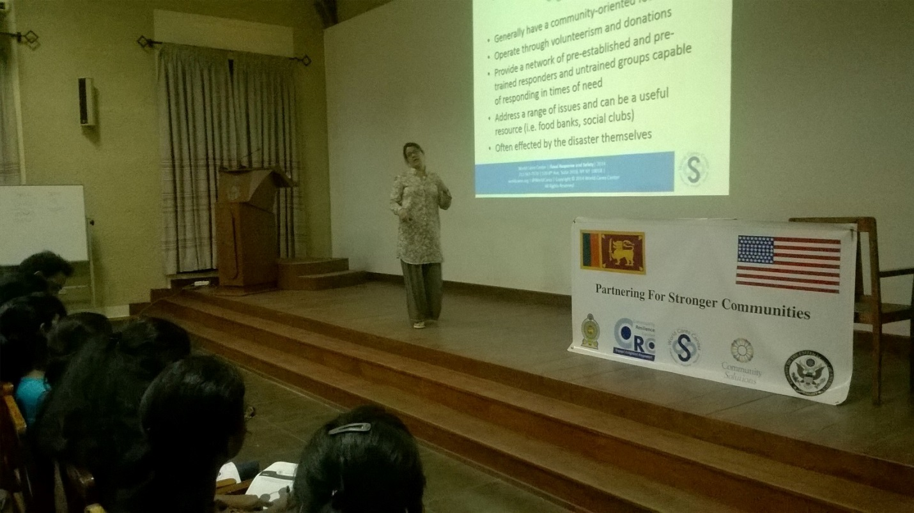
Day 1 of the session was held at the Auditorium of the Faculty of Medicine, University of Colombo.
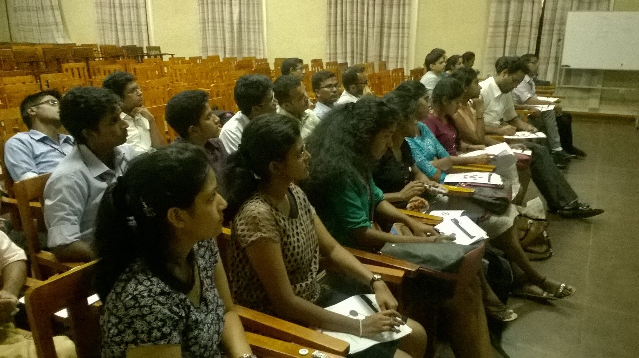
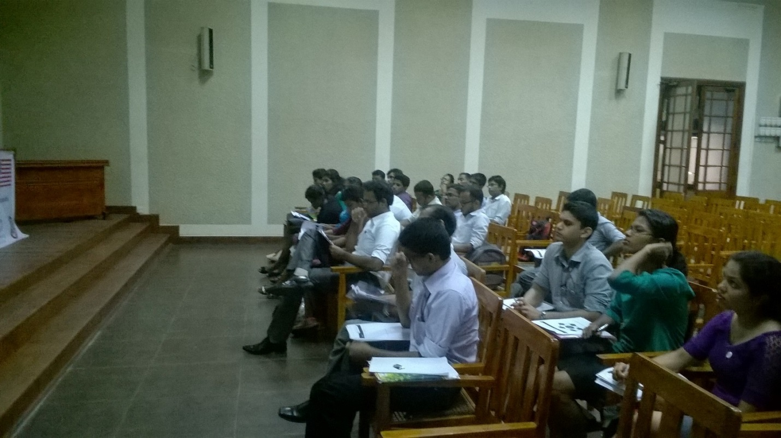
Members of the Core Group for Disaster Relief participating in the training

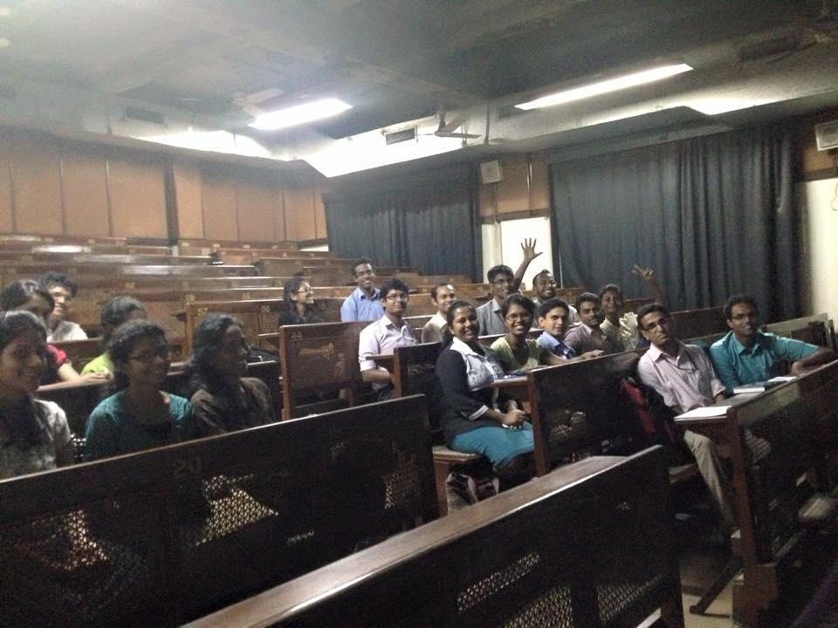
Day 2 of the session was held at the Pathology Lecture Theatre of the Faculty of Medicine,
University of Colombo.
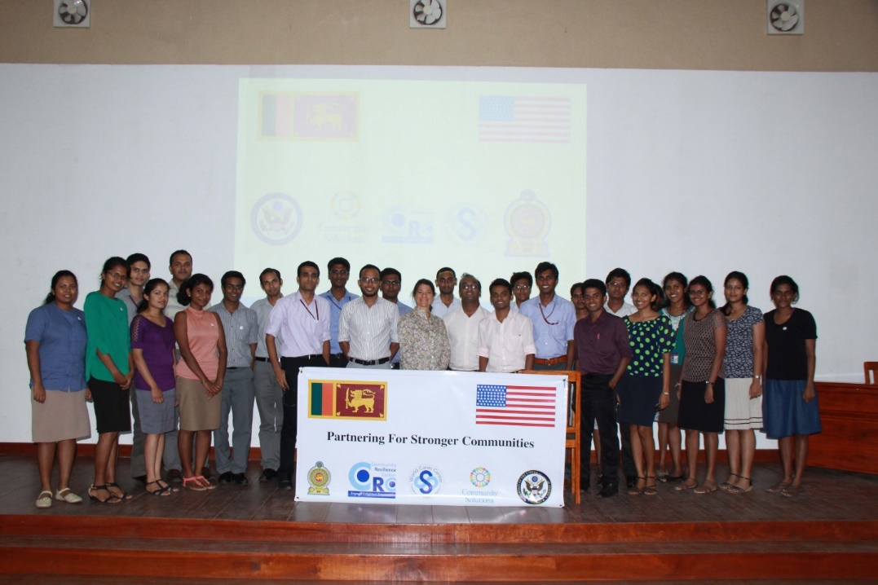
Participants from the Core Group for Disaster Response

Leading and managing training for staff of the Disaster Management Center and university students from the Department of Geography of the University of Colombo
The Disaster Management Center is the national organization responsible for the planning and implementation of the disaster management activities in Sri Lanka. The Leading and Managing training was conducted for 70 participants including disaster management officials including Additional Director General, Director Preparedness and Assistant Directors Awareness and Education Division, Assistant Director Colombo District from the Disaster Management Center and University Students from the Department of Geography, University of Colombo.
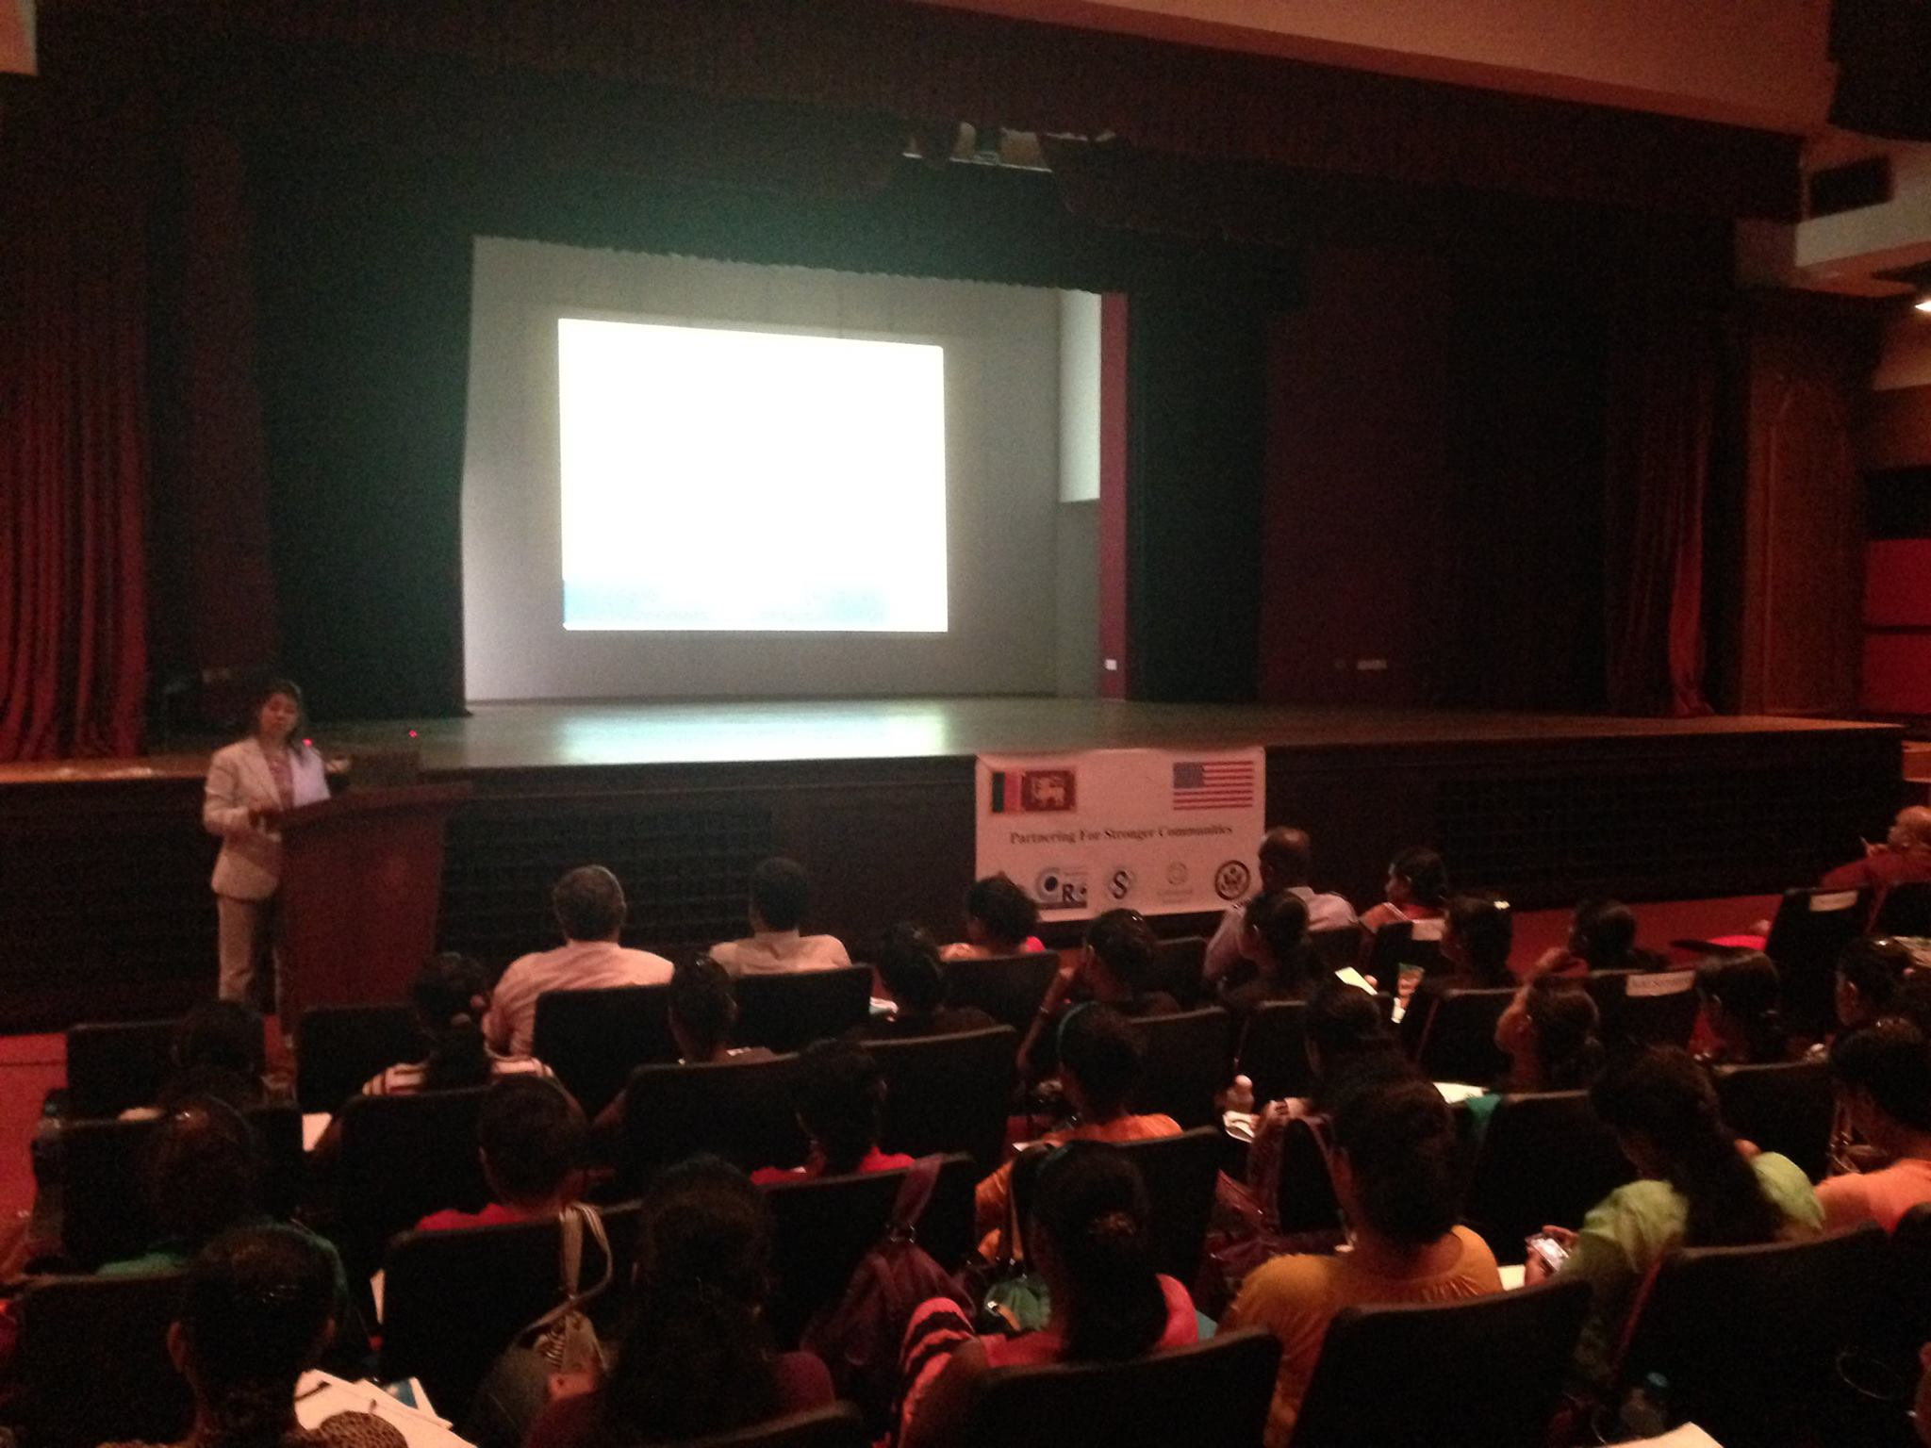

Leading and Managing Training delivered at the Auditorium of the Ministry of Disaster Management

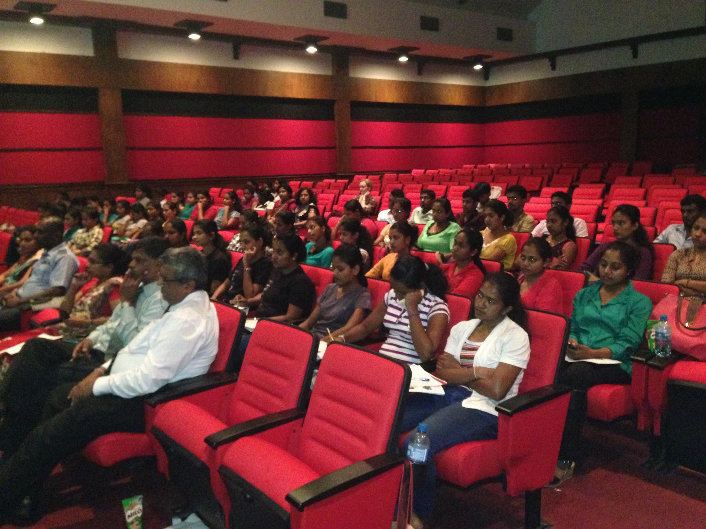
Disaster Management Center Officials and University Students participating in the Leading and Managing Training

Establishment of a Volunteer
Leading and managing training for doctors of Health Sector Disaster Management Training
The Post Graduate Institute of Medicine, University of Colombo offers a one year postgraduate diploma course to doctors (medical officers) in Health Sector Disaster Management. This one year program consists of 6 months of lectures and 6 months of hospital attachment. During the hospital attachment, the trainees will carry out a risk assessment, prepare an emergency preparedness plan and conduct a disaster management drill for the hospital with the participation of all stakeholders. The training was conducted for graduates from the 2013 and 2014 batches and trainees from 2015 batch. Total number of doctors who participated in the training was 24.
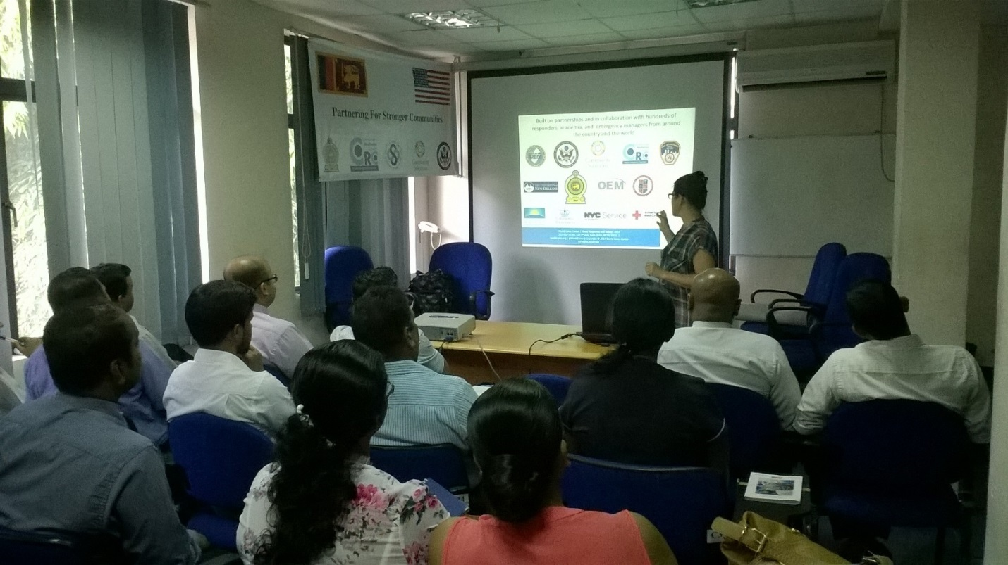
The Leading and managing training for Health Sector Disaster Management Diploma doctors was held at the Auditorium of Management, Planning and Development Unit of the Ministry of Health, Colombo.
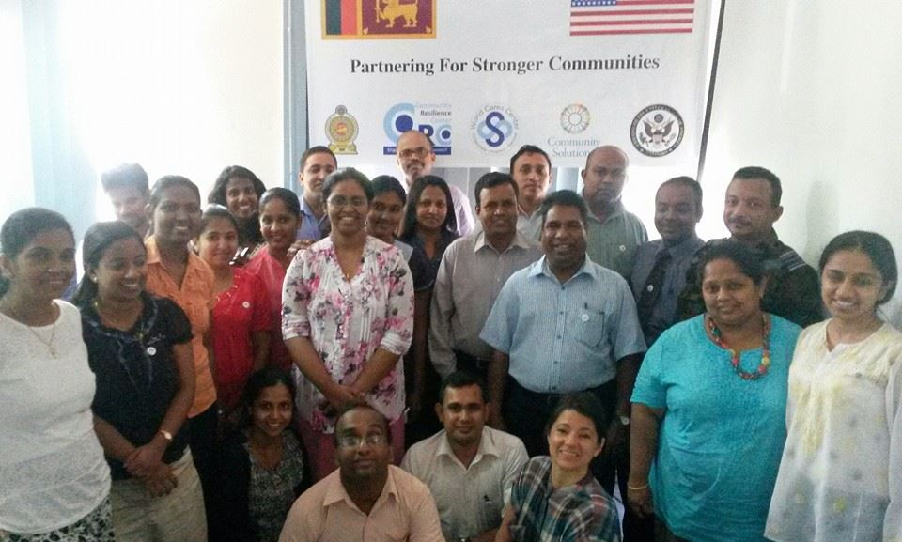
Participants of the Leading and Managing Training for Doctors of the Health Sector Disaster Management Diploma Course

Reviewing the Leading and Managing Training
Having completed three rounds of Leading and Managing training for three diverse target groups, it was high time to obtain in-depth participant feedback on the training in addition to the feedback obtained at the end of each session. Six Key participants from all three trainings were invited for an in-depth participant feedback session. These inputs were very useful in culturally adopting the training for Sri Lanka.

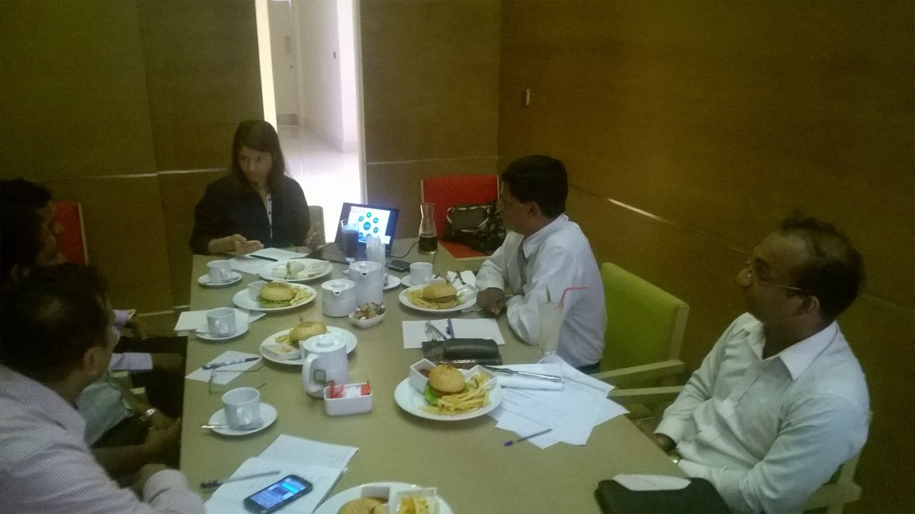
In-depth feedback on the Leading and Managing Training by participants

Leading and managing training for staff and volunteers of Foundation of Goodness, Seenigama, Galle
The Foundation of Goodness was set up by Mr. Kushil Gunasekara 1999, to provide essential services to his ancestral village of Seenigama. Since then, he has been joined by a dedicated Board of Trustees and a committed team based in Seenigama and Colombo, all working together with villagers and donors to uplift the lives of rural communities in Sri Lanka. At present, the Foundation of Goodness carry out a large number of community service programs and are engaged in innovative self-sustainability activities. Leading and managing training was conducted for the staff and volunteers of the Foundation of Goodness. In addition, staff and volunteers from the Community Tsunami Early-warning Center also participated in this training. Total number of participants of this training was 34. This provided the opportunity to obtain experience in delivering the Leading and Managing training to a civil society organization which manages volunteers as a part of their day to day operations.
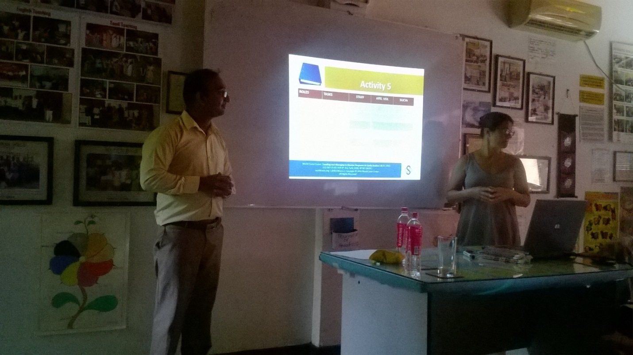
Ms. Lisa Orloff and Dr. Novil Wijesekara co-facilitating the Leading and Managing training.

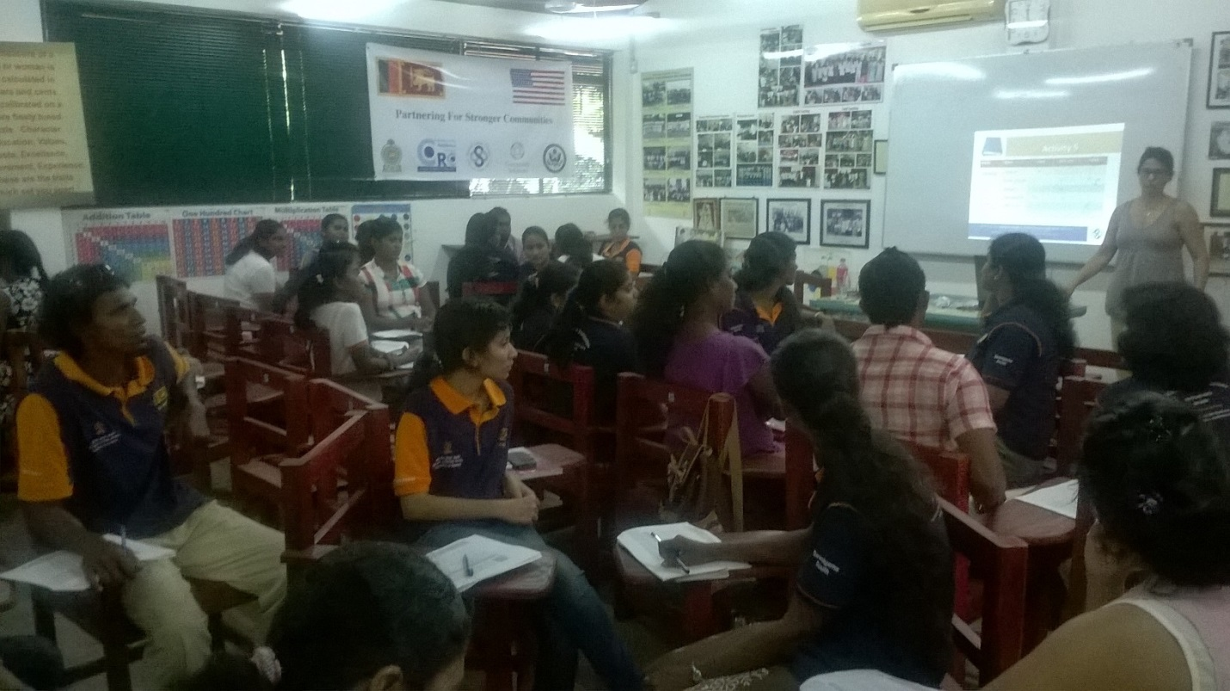
Leading and Managing training at Business Skills Development Center of Foundation of Goodness

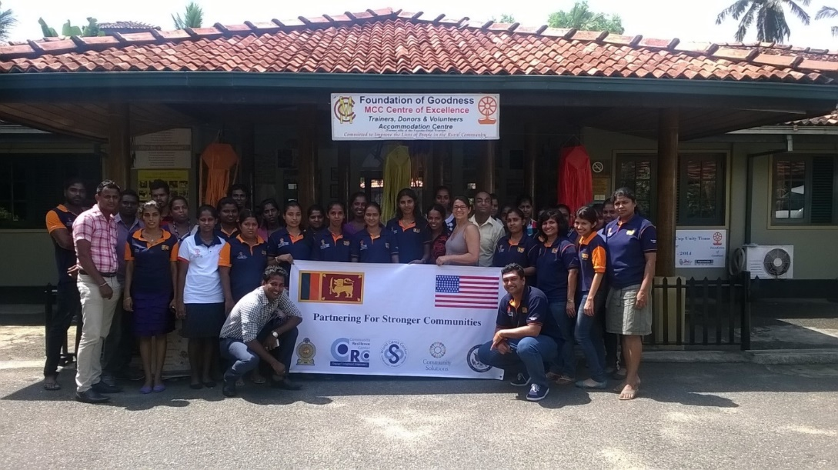
Participants of Leading and Managing Training at Foundation of Goodness

Lecture at the Colombo Fire Brigade
A Special lecture for the staff of Colombo Fire Brigade on " Celebrating our everyday heroes: from New York City to Colombo City." by Ms. Lisa Orloff. She shared her lessons learnt through supporting the Fire Fighters through 9/11 incidents. Ms. Suni Dawn, Head of the Cultural Section and Ms. Dushinka Abayasekara, Alumni Coordinator of the US Embassy Colombo graced this occasion. Total number of participants for this lecture was 60. Ms. Lisa Orloff presented a coat which had the badges of the Fire Brigades of the five boroughs of the New York City to the Chief Fire Officer Mr. P N R Fernando.
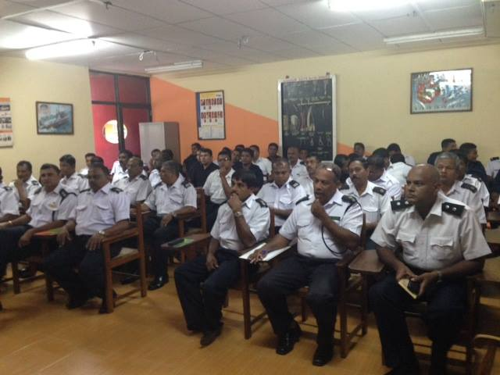
The Lecture was held at the Auditorium of the Fire Brigade of the Colombo Municipal Council;

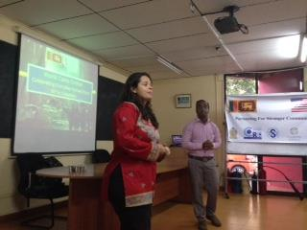
Ms. Suni Dawn, Head of the Cultural Section and Ms. Dushinka Abayasekara, Alumni Coordinator of the US Embassy Colombo graced this occasion.

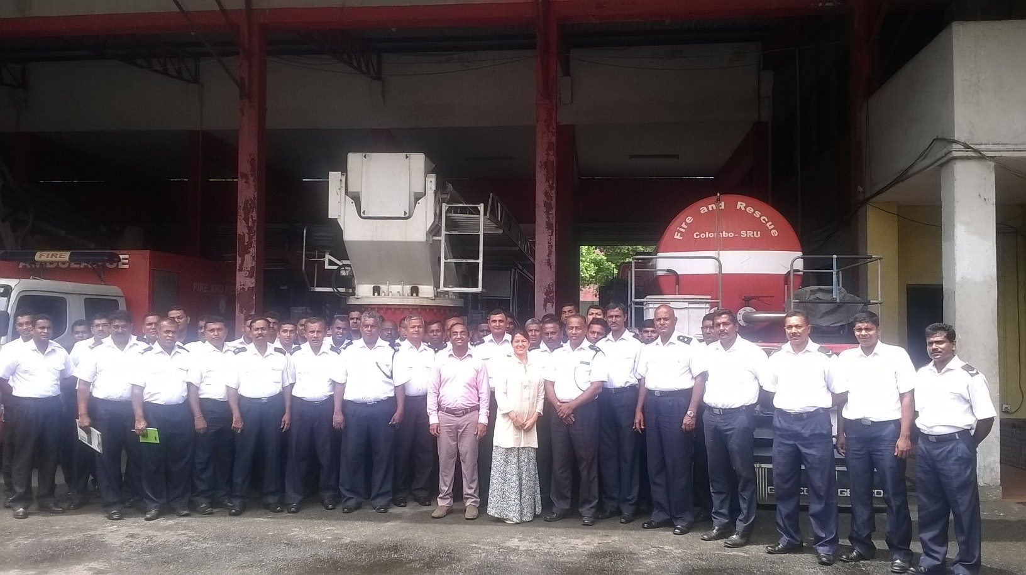
Participants of the Lecture: " Celebrating our everyday heroes: from New York City to Colombo City."
- Technical support for the Colombo Municipal Council to apply for the 100 Resilient Cities program
Hundred resilient cities is a program pioneered by the Rockefeller Foundation where cities are provided an opportunity to enhance its resilience through an intense exercise of identifying resilient challenges and taking measures to address them. The Community Resilience Center technically supported the Colombo Municipal Council in compiling its application for the 100 Resilience Cities challenge and completed the application on behalf of the Colombo Municipal Council.

- Community Resilience Training for Urban Communities
This project was conducted in an urban slum area in Mattakkuliya area. Community awareness programs were conducted on three key disaster preparedness messages: 1. Know the hazards in your area. 2. Prepare a disaster preparedness plan. 3. Assemble an emergency supply kit.

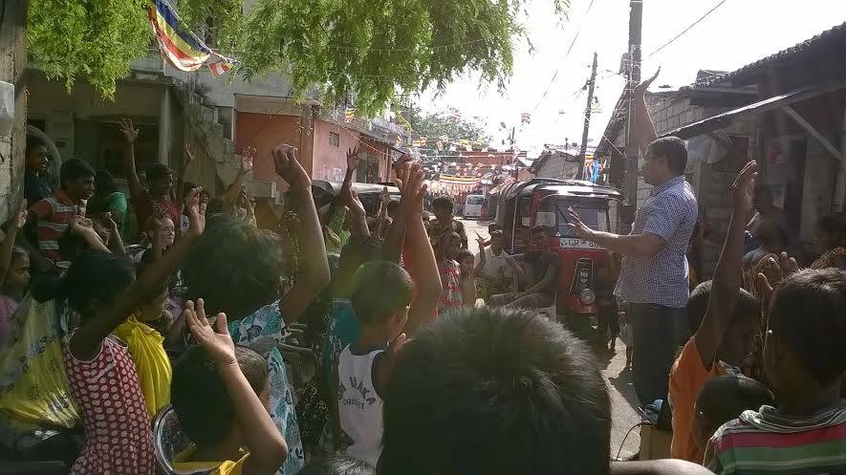

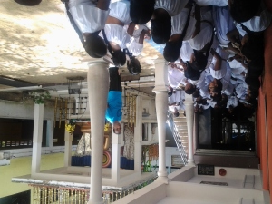
- Community Resilience Training for Venerable from Myanmar
The Community Resilience Center conducted a training on community resilience for Venerables from Myanmar who are currently learning Buddhism in Sri Lanka.

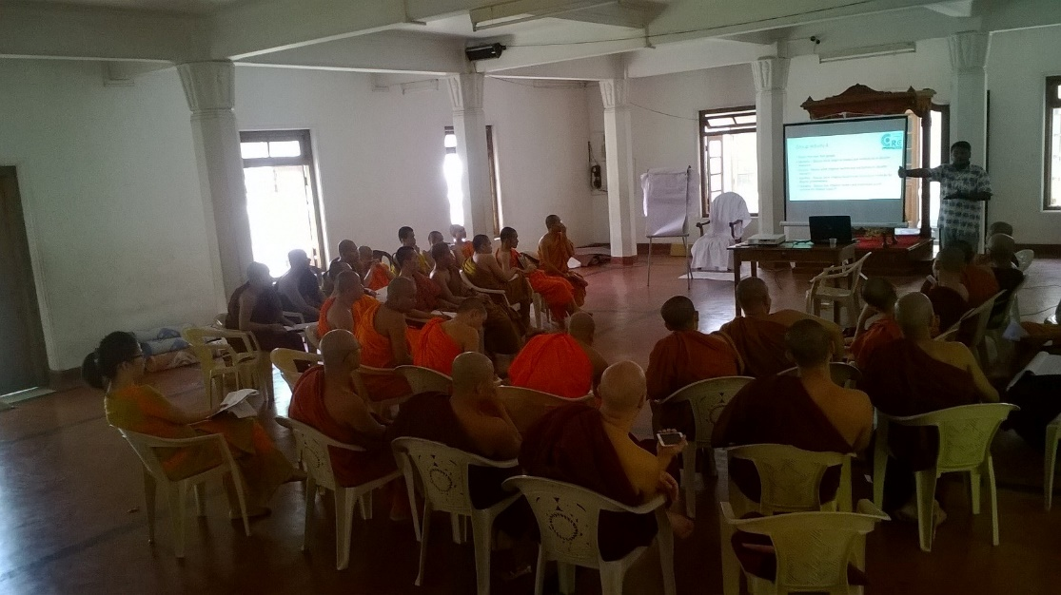

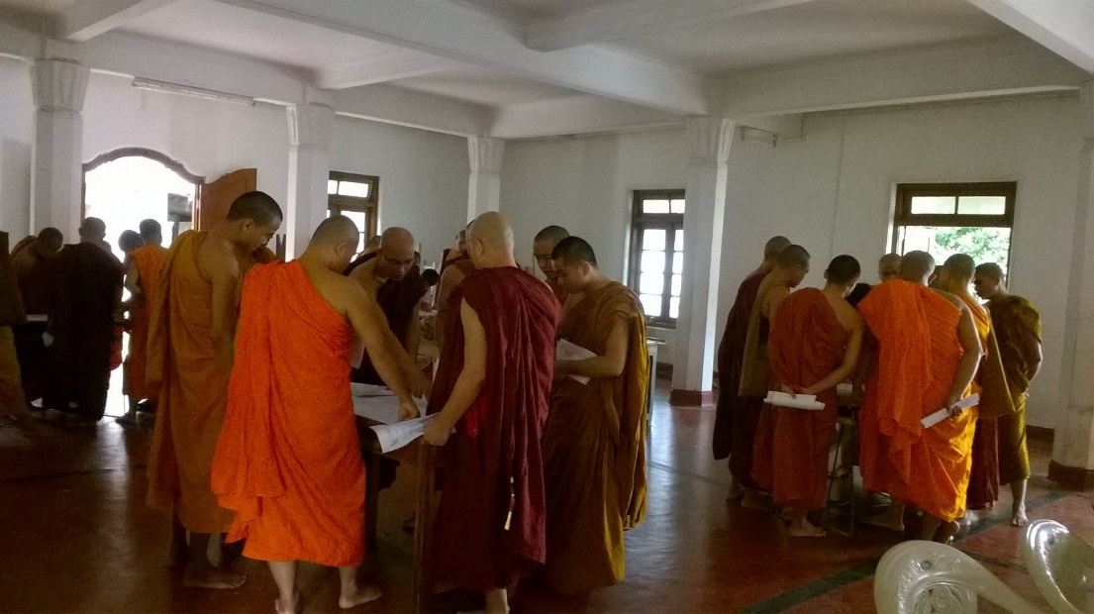

- First Aid Training for attendants at Teaching Hospital Anuradhapura
Community Resilience Center provided technical support for the First Aid Training for attendants at Teaching Hospital Anuradhapura.

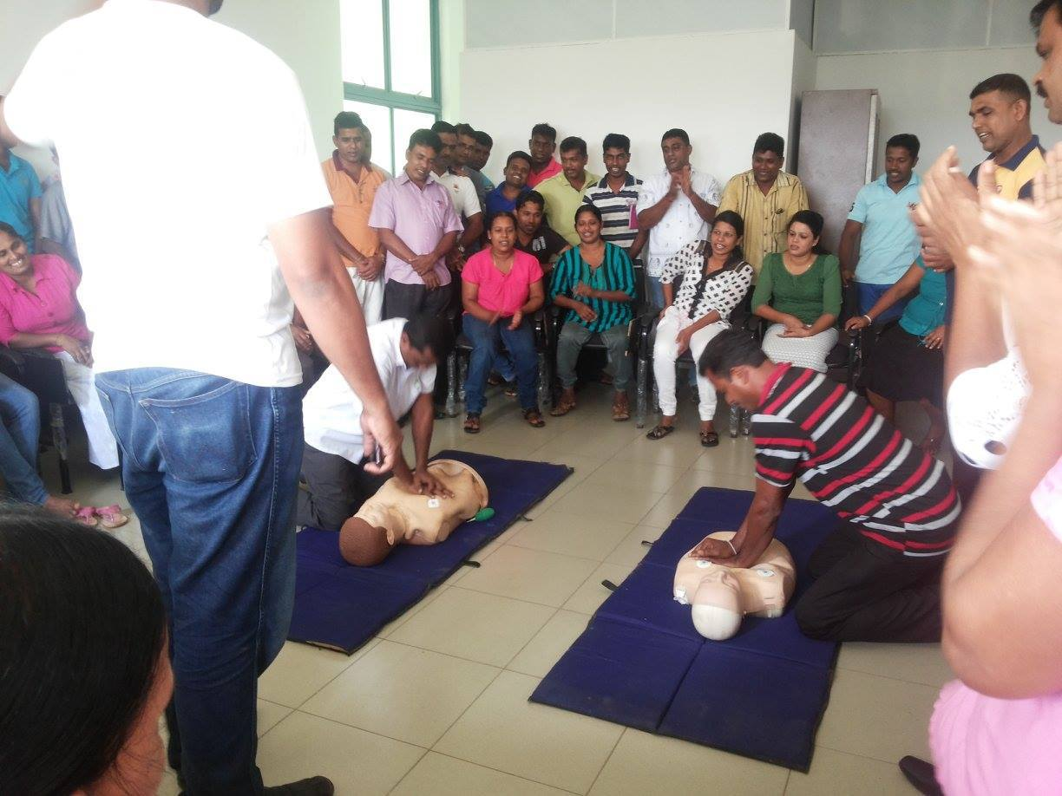

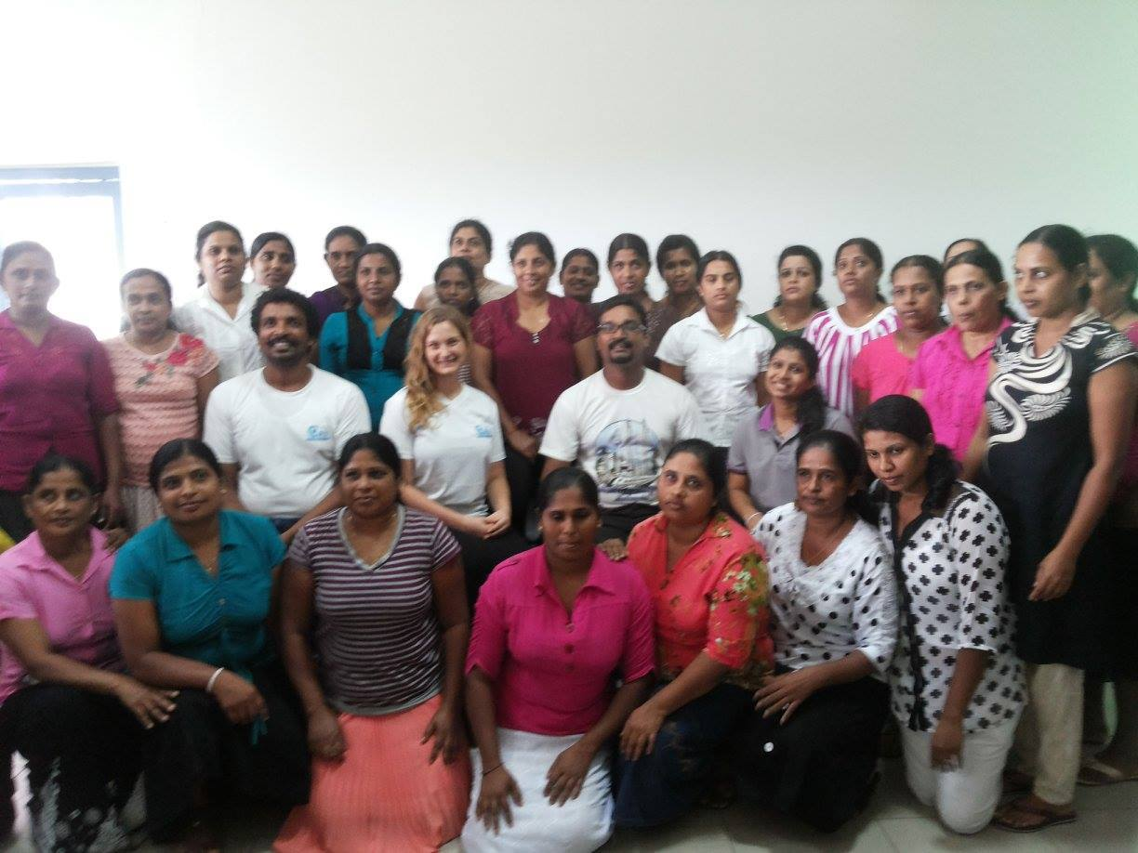

- Contribution for the School Disaster Management Volunteers Program
Community Resilience Center provided technical support for the development and conduction of School Disaster Management Volunteers Program by the Disaster management Center.

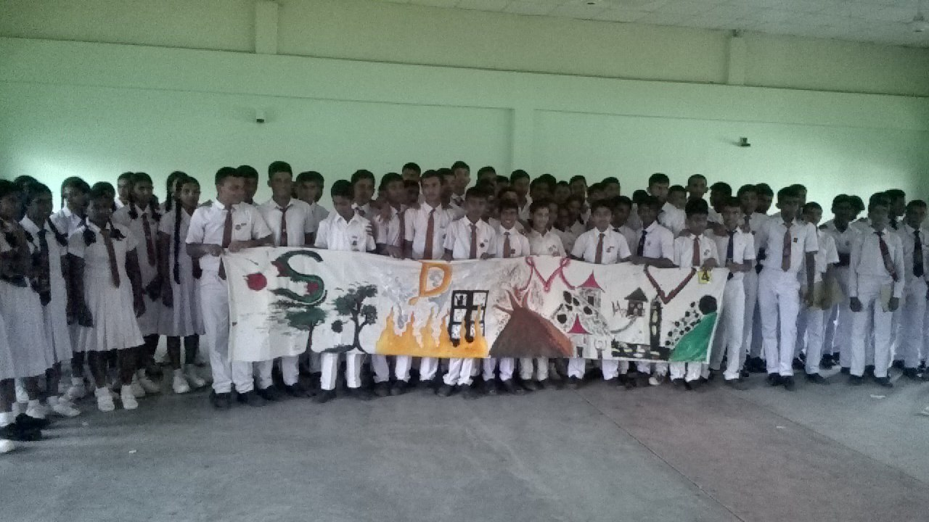

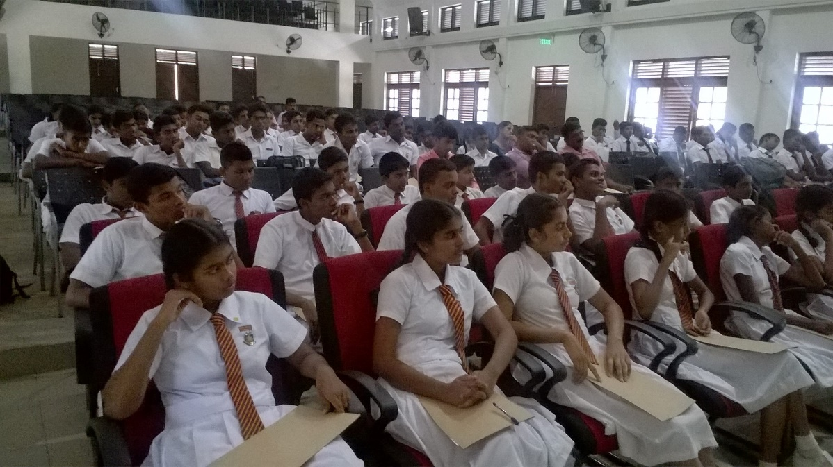

- Contribution for Youth Disaster Management Volunteer Program
Community Resilience Center provided technical support for the development and conduction of Youth Disaster Management Volunteer Program by the Disaster management Center.

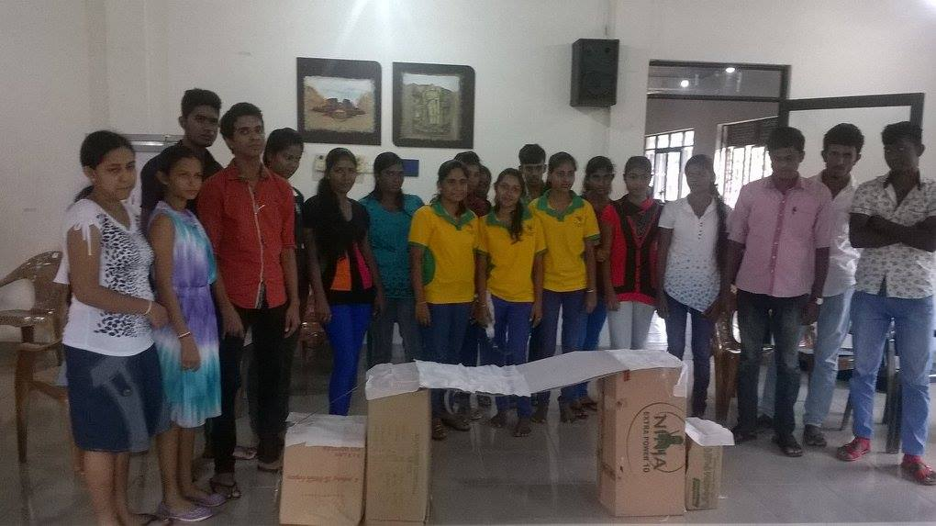

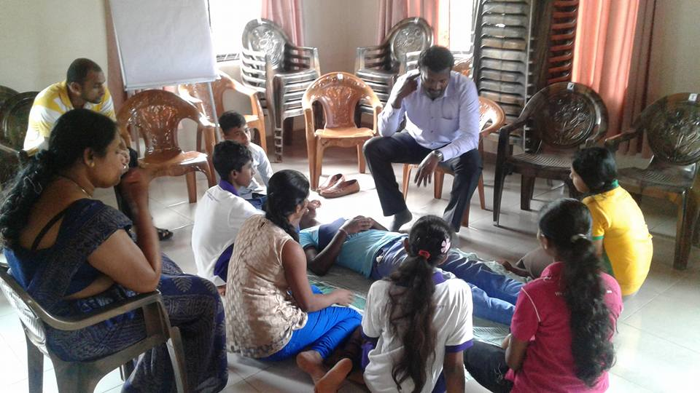

- Contribution for Professional Disaster Management Volunteer Program
Community Resilience Center provided technical support for the development of Professional Disaster Management Volunteer program by the Disaster Management Center.

- Establishment of Community Tsunami Museum and Education Center
Community Resilience Center provided technical support for the establishment of the Community Tsunami Museum and Education Center in Peraliya, Thelwaththa, Sri Lanka. In addition, number of community awareness programs have been conducted on disaster preparedness with special emphasis on Tsunami.

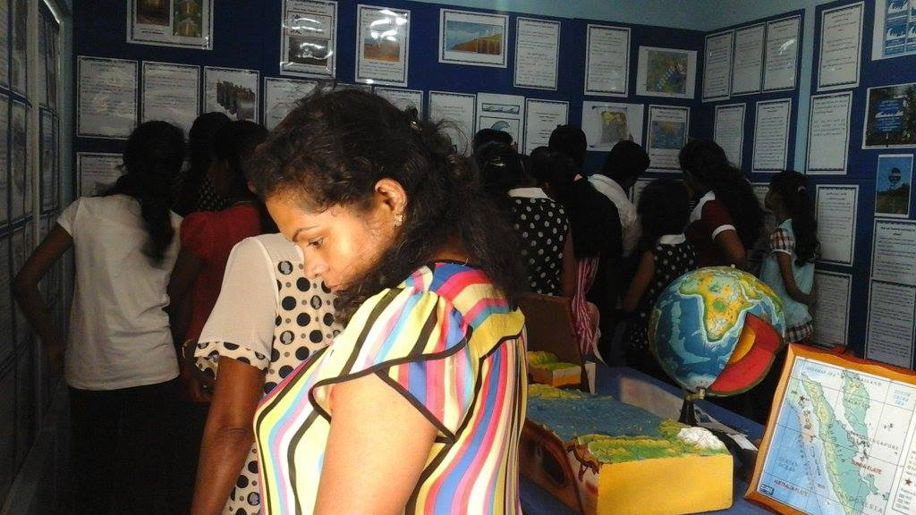

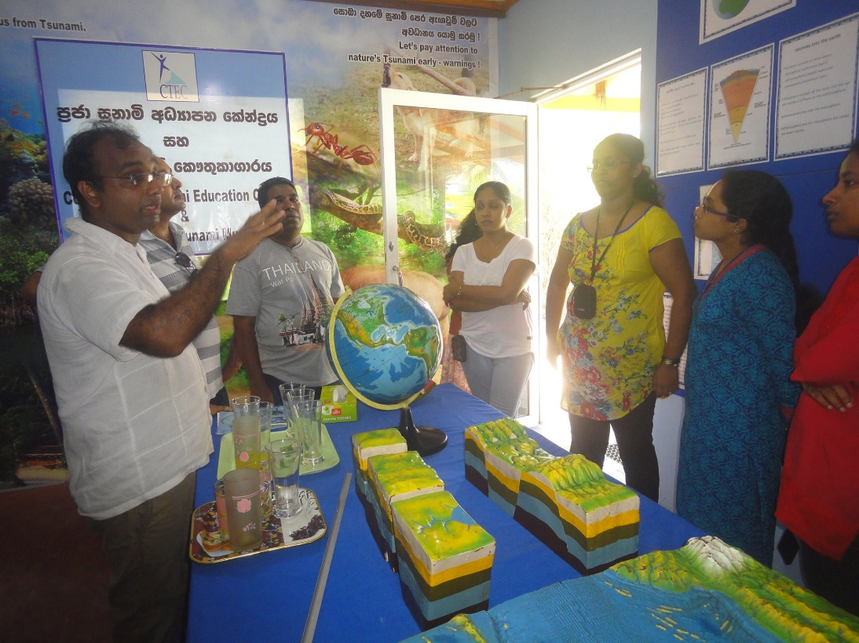

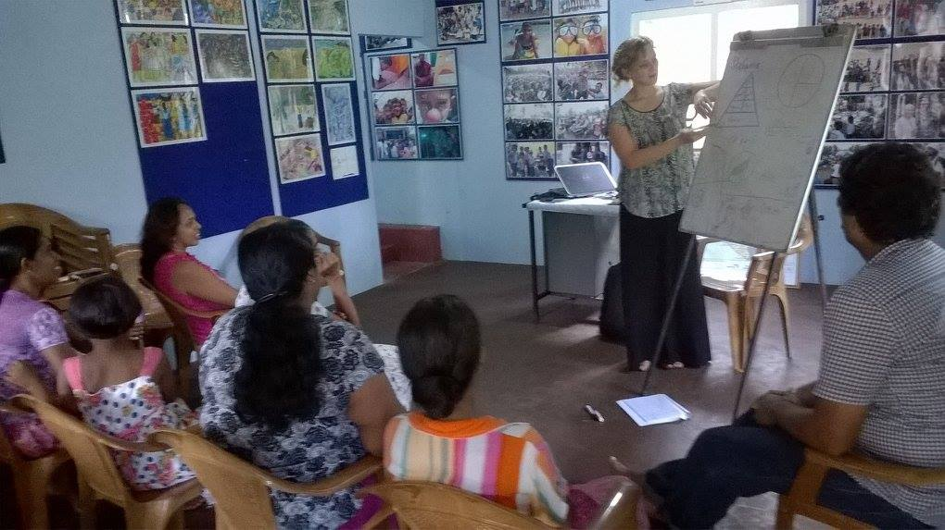

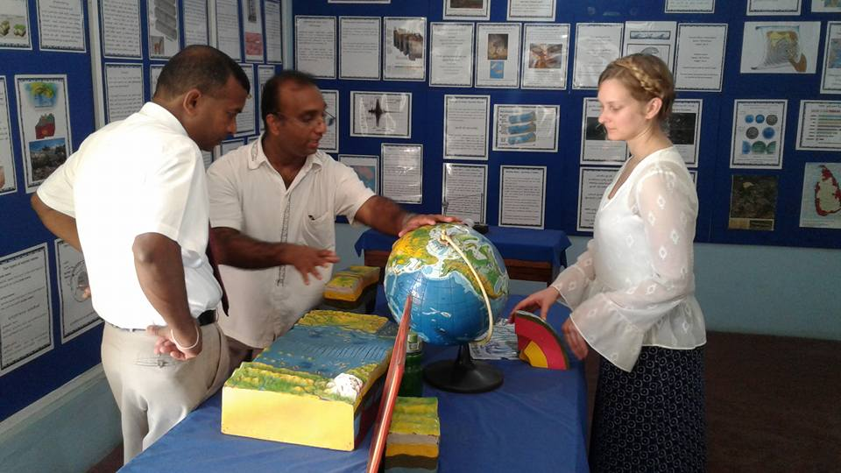

10. Psychosocial activities at Mahadeva Achchiram Orphanage Kilinochchi

This project was conducted to provide assistance to needy children at the Mahadeva Achchiram Orphanage Kilinochchi and to engage in psychosocial activities with the children. The project was conducted in collaboration with the Army Forces in the area.
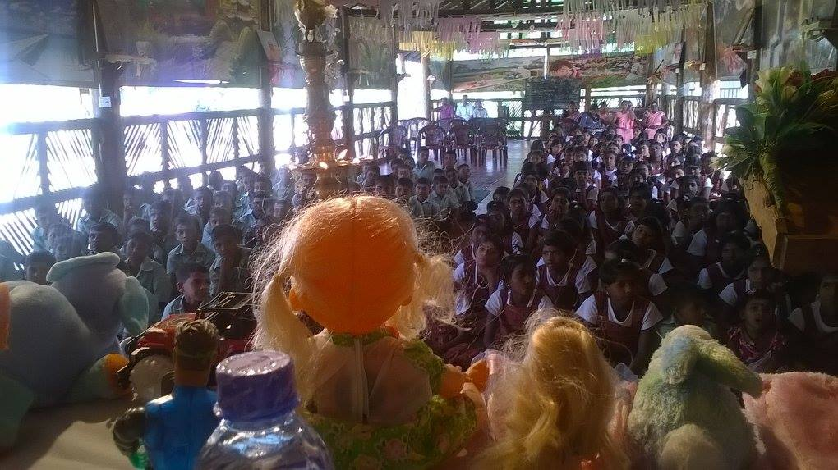

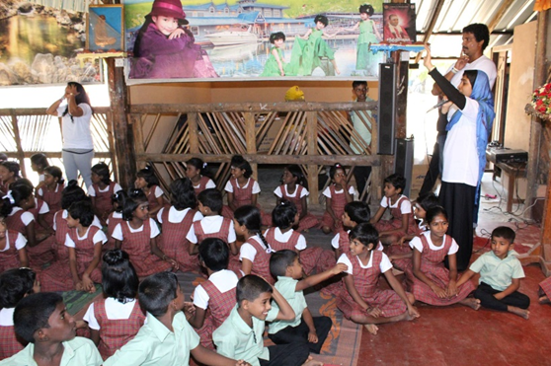

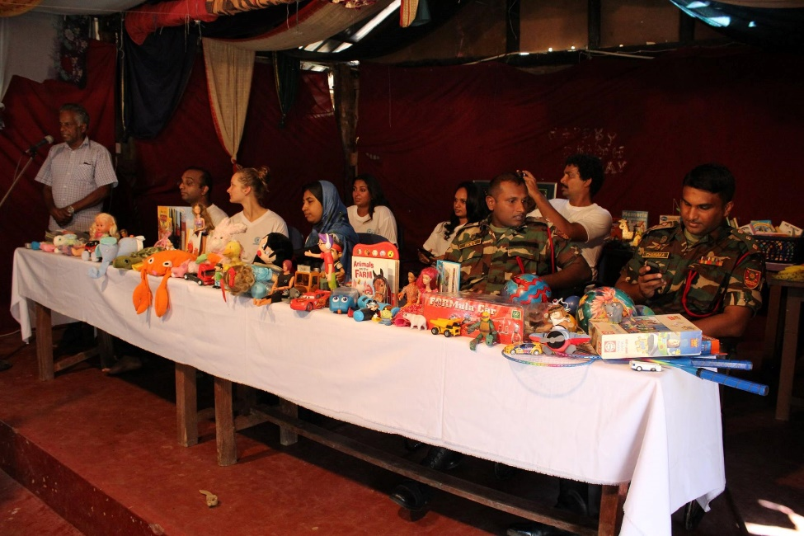

Curriculum Vitae of

Community Resilience Center members

Our Partners

